Algebra 1: Unit 13, Lesson 10

- The table of values for function $f(x)$ is shown.
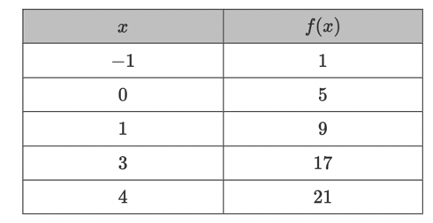
What type of graph represents $f(x)$?
Linear

- Peter and Brian are working together on identifying types of functions from descriptions. The following description is given for a function. “The $y$-values of function $M(x)$ decrease as the $x$-values decrease. The $y$-values decrease by a factor of $0.25.$"
Peter states the function is linear and Brian states the function is exponential decay. Who is correct?
Brian is correct.

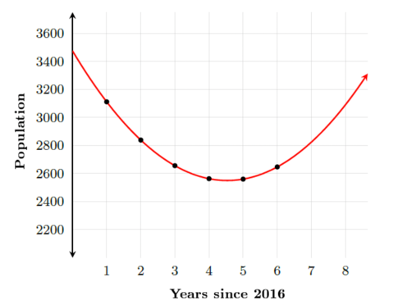
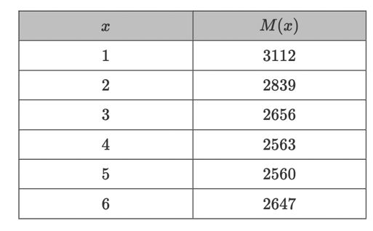
- The table of values models the growth of population, $M(x)$ in a small town in rural Florida, $x$ years since 2016. The graph of the function to model this scenario is also shown.

The $M(x)$ values are not changing at a constant rate. The graph that represents the values in the table is what type of graph?
Quadratic

